Zomato Data Analysis Report

**📌 1. Project Title**

*Zomato Restaurant Data Analysis Using Python*

**🎯 2. Project Objective**

The objective of this project is to analyze restaurant data from Zomato to uncover insights about customer behavior, restaurant performance, and service preferences using Python. The analysis focuses on restaurant types, order modes, ratings, and cost patterns.

**📘 3. Key Concepts**

* Data Cleaning
* Exploratory Data Analysis (EDA)
* Grouping and Aggregation
* Statistical Insights
* Business Intelligence

**🛠 4. Technology Used**

* Python (Pandas, Matplotlib, Seaborn)
* Jupyter Notebook
* MS Word for reporting

**🔍 5. Business Questions & Answers**

* All 6 questions you provided, with full analysis and tables (as earlier shown)

# Questions & Answers

## 1. What type of restaurant do the majority of customers order from?

Dining restaurants are the most popular, with 110 entries in the dataset.

## 2. How many votes has each type of restaurant received from customers?

|  |  |
| --- | --- |
| Restaurant Type | Total Votes |
| Dining | 20363 |
| other | 9367 |
| Cafes | 6434 |
| Buffet | 3028 |

## 3. What are the ratings that the majority of restaurants have received?

Most restaurants received ratings between 3.3 to 4.2. The most common rating is 3.8 (20 restaurants).

## 4. What is the average spending on each online order (by couples)?

The average spending on each online order is approximately ₹510.34.

## 5. Which mode (online or offline) has received the maximum rating?

Online orders have a higher average rating (3.86) compared to offline orders (3.49).

## 6. Which type of restaurant received more offline orders?

Dining restaurants again top the list with 77 offline order entries.

Let’s add code:

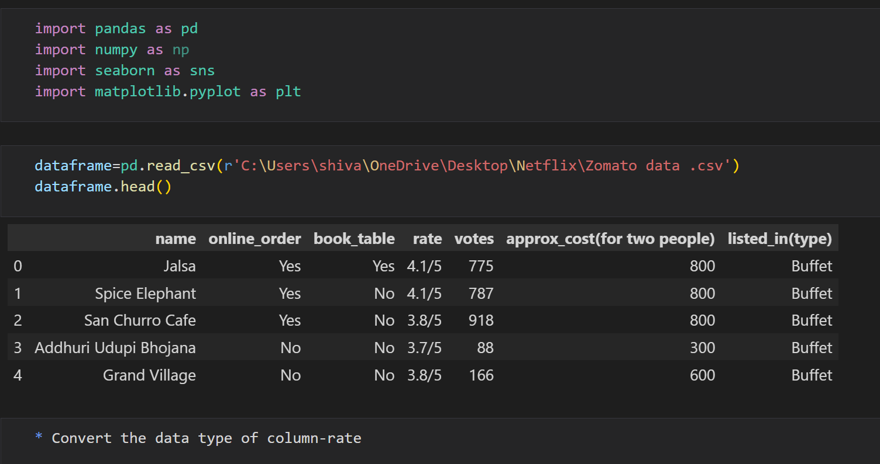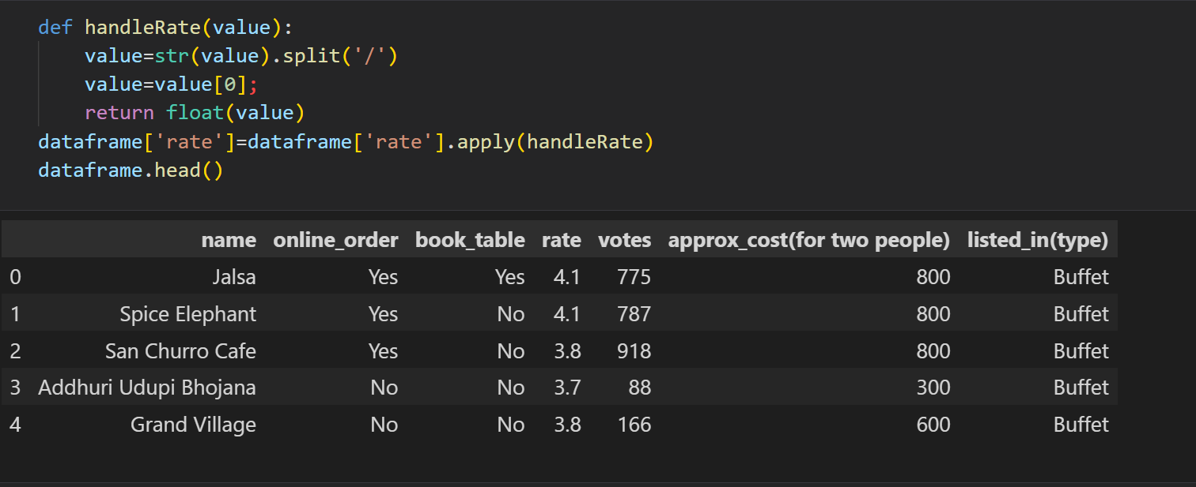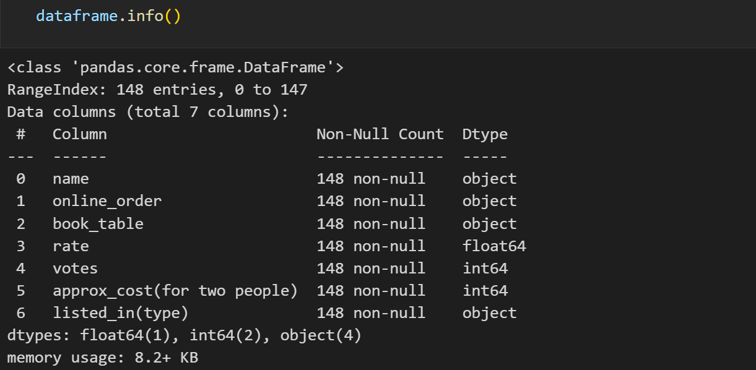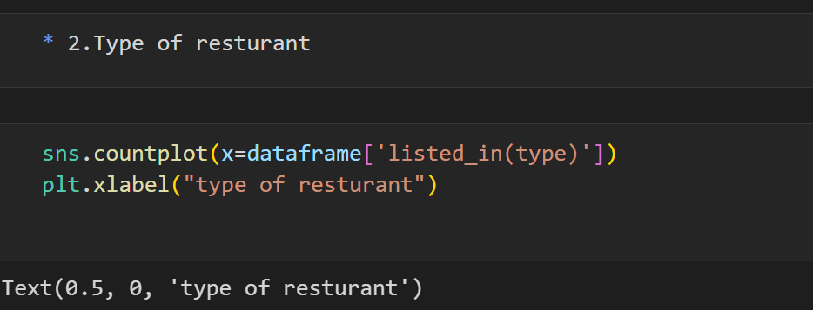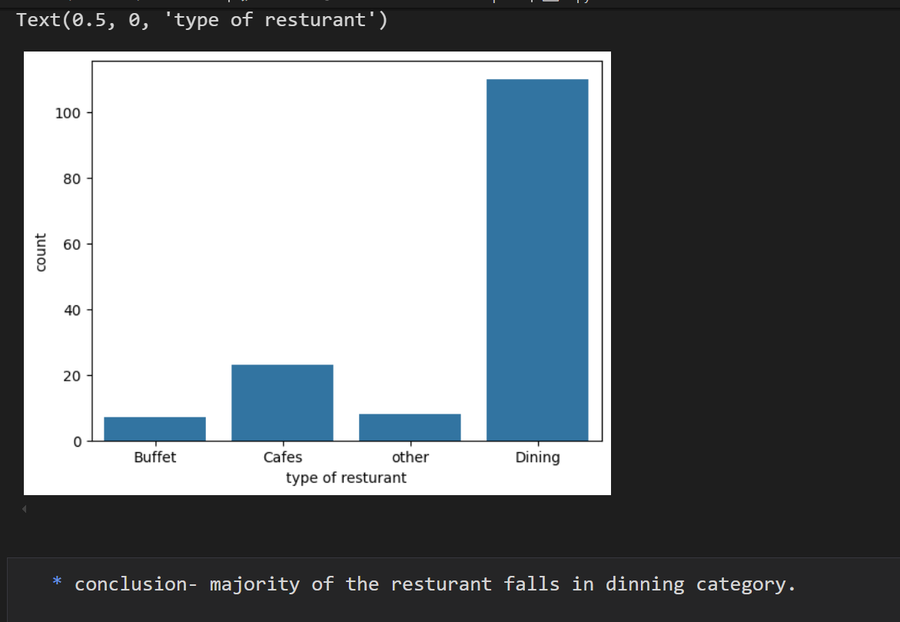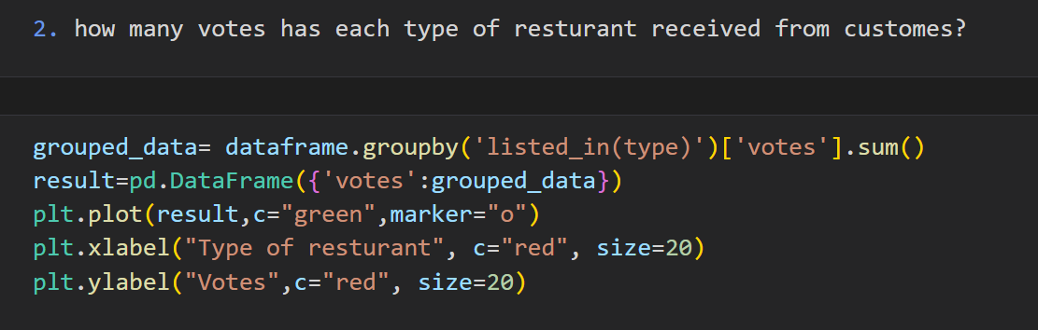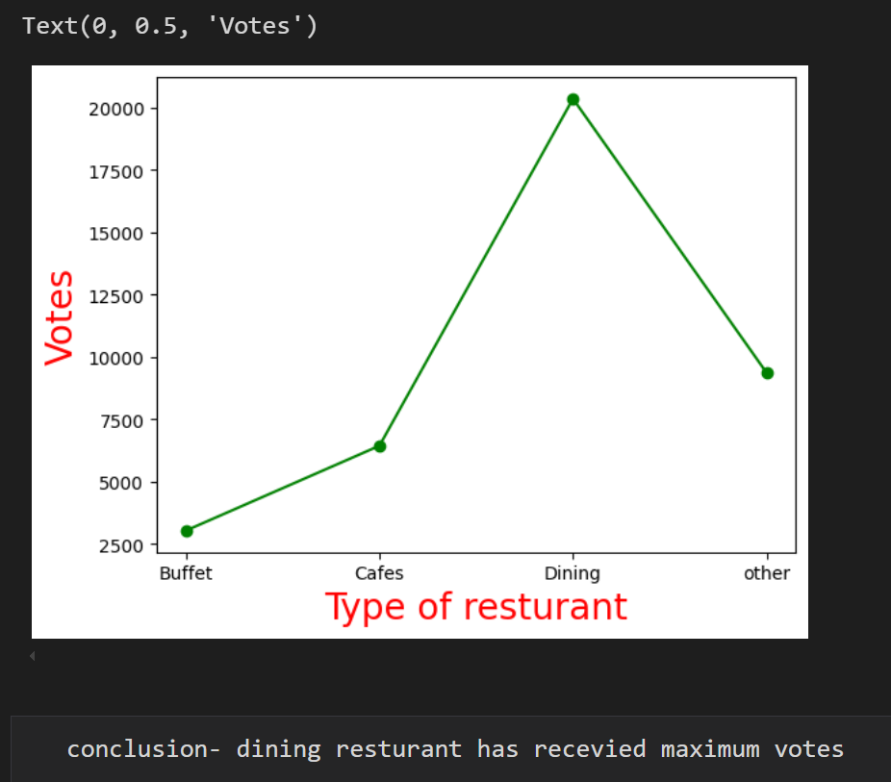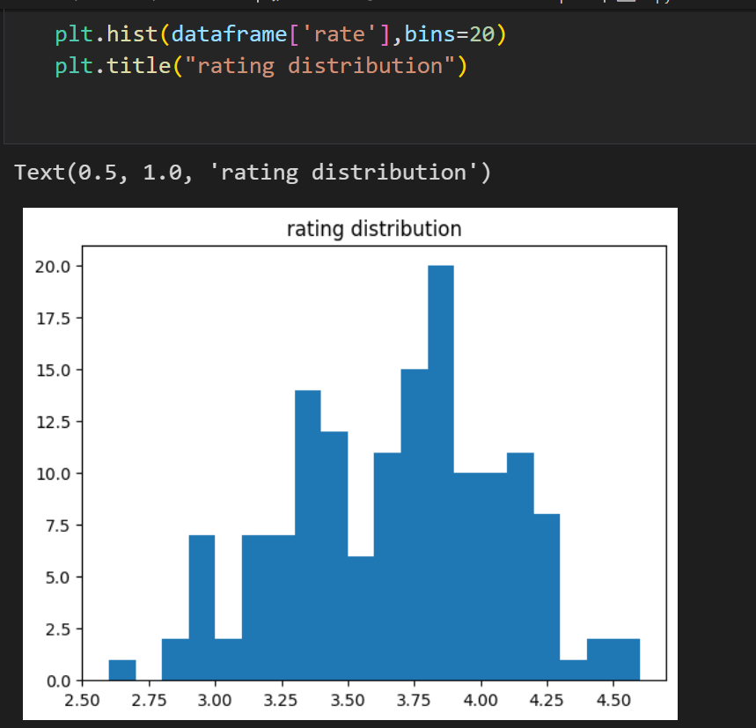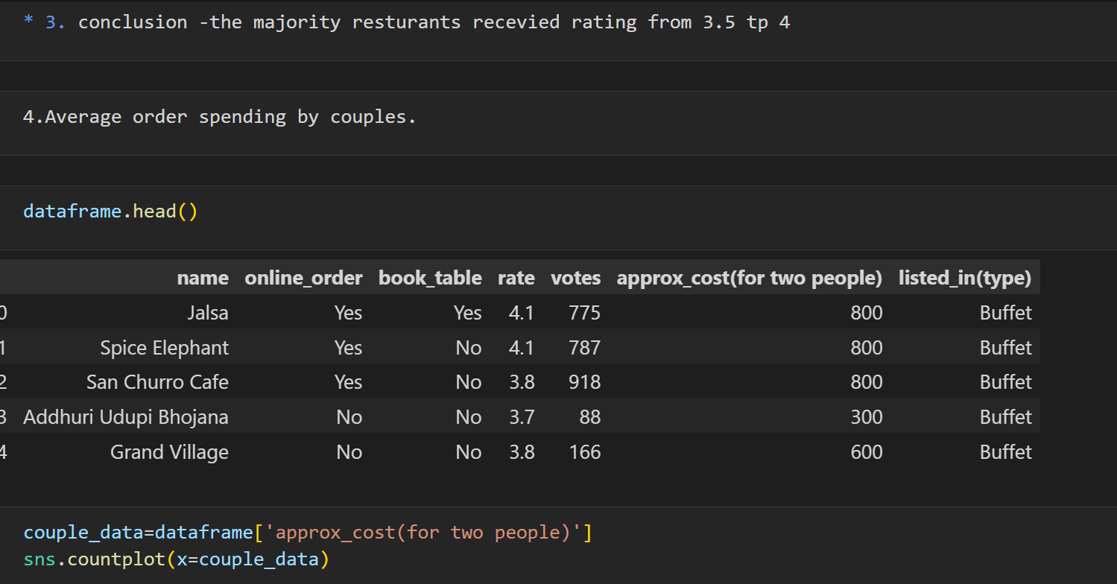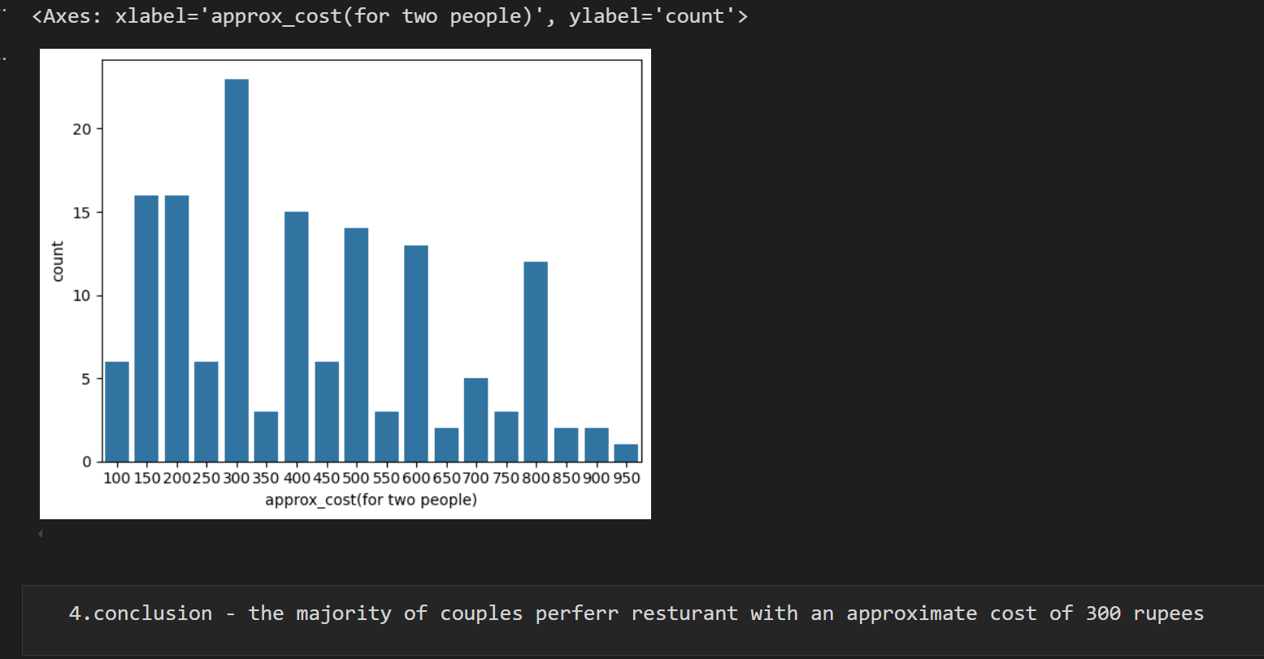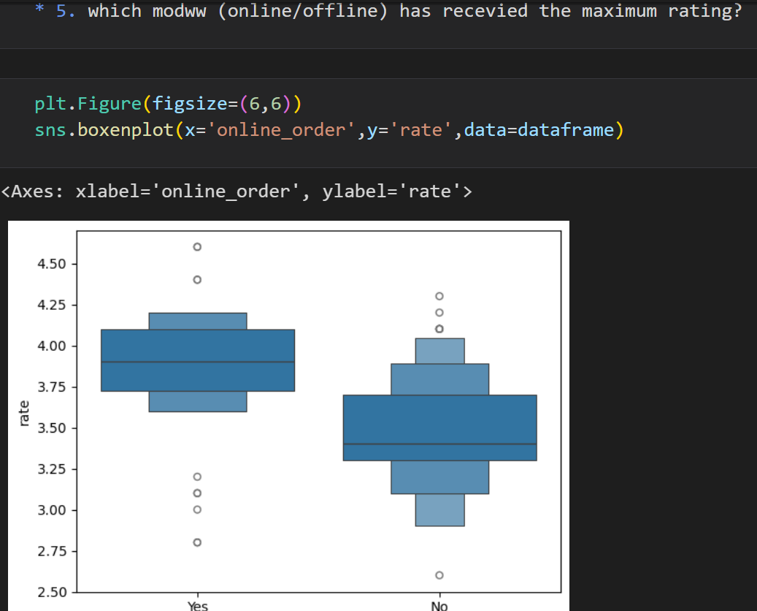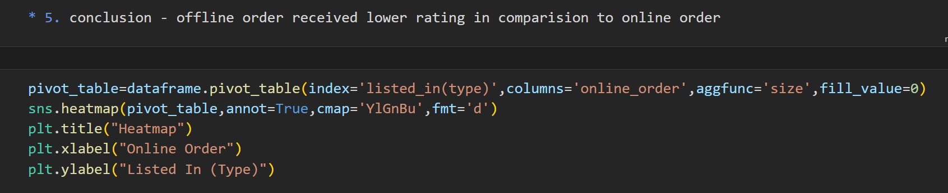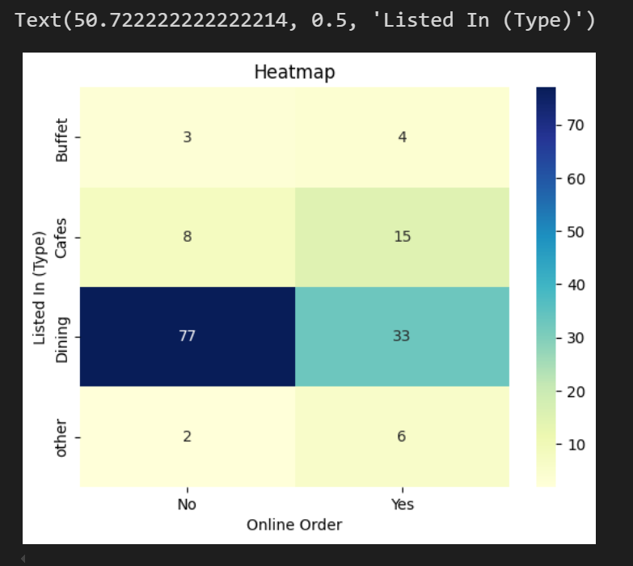

**🧾 6. Project Summary**

The analysis shows that Dining restaurants are most popular, online orders receive better ratings, and average spending per online order is ₹510. These insights help Zomato identify key business areas to improve customer experience and drive engagement.